A simple demonstration for Medical Booing System

## RELATED EXPERIENCE

## Web Developer

Our Team developed a Medical booking System

As a Web Developer, my responsibilities include:

|  |
| --- |
| Responsibilities:   * Utilized programming capabilities in PHP, SQL and JavaScript and other libraries as needed. * Converted mock-up into HTML, JavaScript, AJAX and JSON. * Built website interfaces with HTML and CSS. * Applied knowledge of JavaScript and Object-Oriented Programming to create successful designs. |
|
|

I worked with the team to accomplish project goals. In the end, our project meets both deadline and requirements.  Bootstrap and PHP were used to construct the web application while MySql as database system. Please visit our product marketing website at the following address.  <https://infs3202-3e505d70.uqcloud.net/>

1.Patient and doctor can sign in by choosing their role at the sign in page, and they need fill up the verify code to login, they also can click remember me to save their account and password to the cookie.

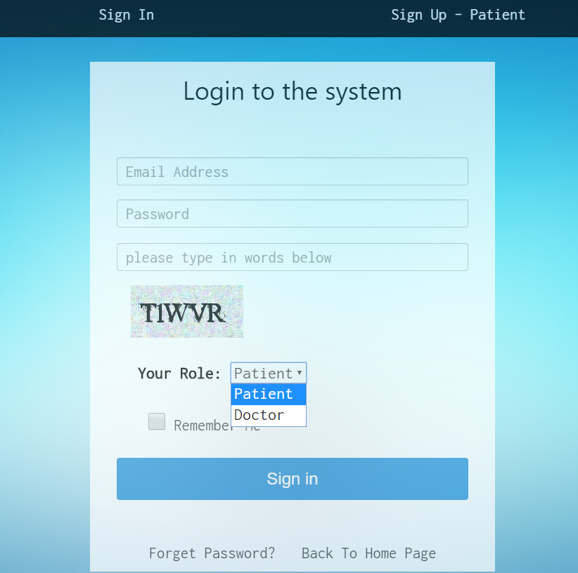

2. There are sign up pages for patient and doctor, respectively.

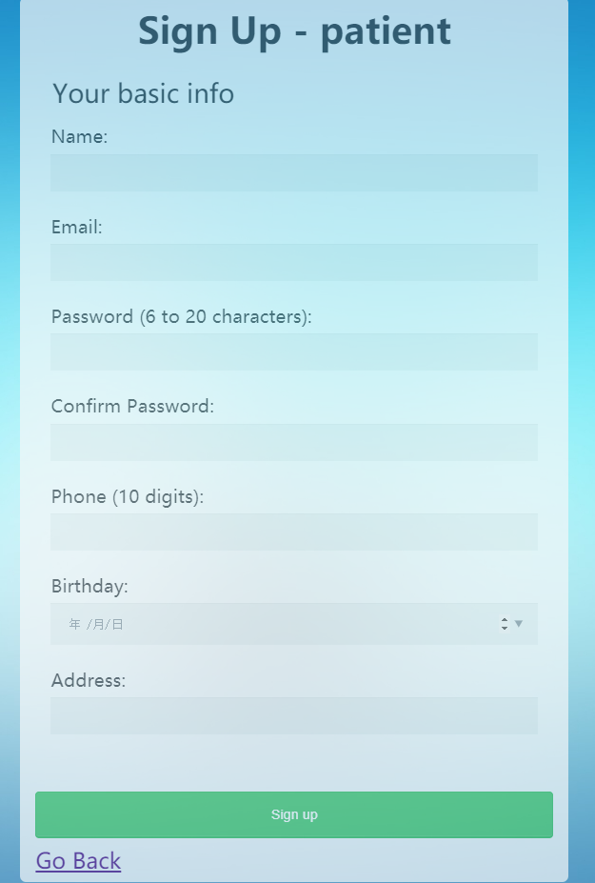

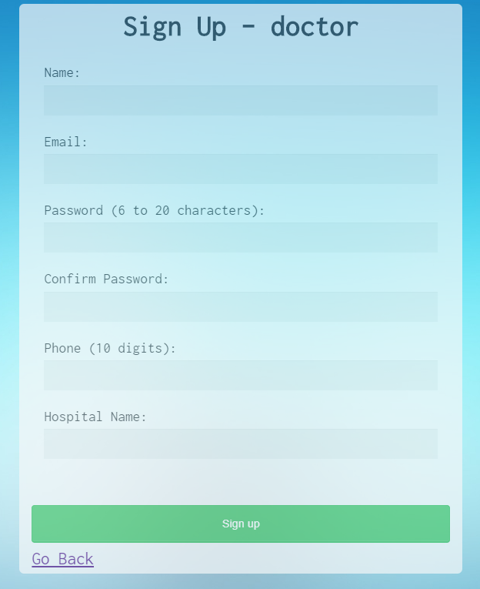

3. Booking History for patient, they can manage their booking and see their booking status here.

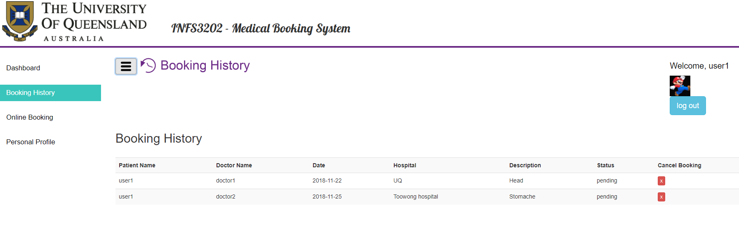

4. Online booking page for patient. Patient can view doctor information here and book an appointment here.

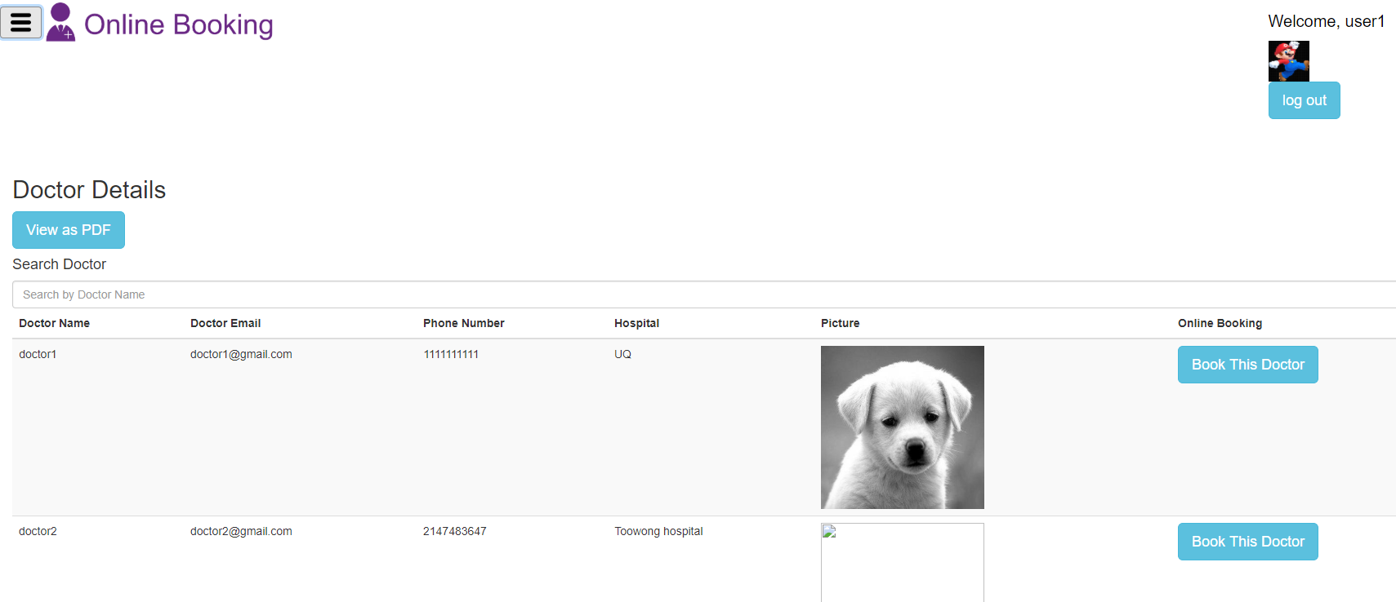

5. Patient can select the date and search the hospital by Google Map API.

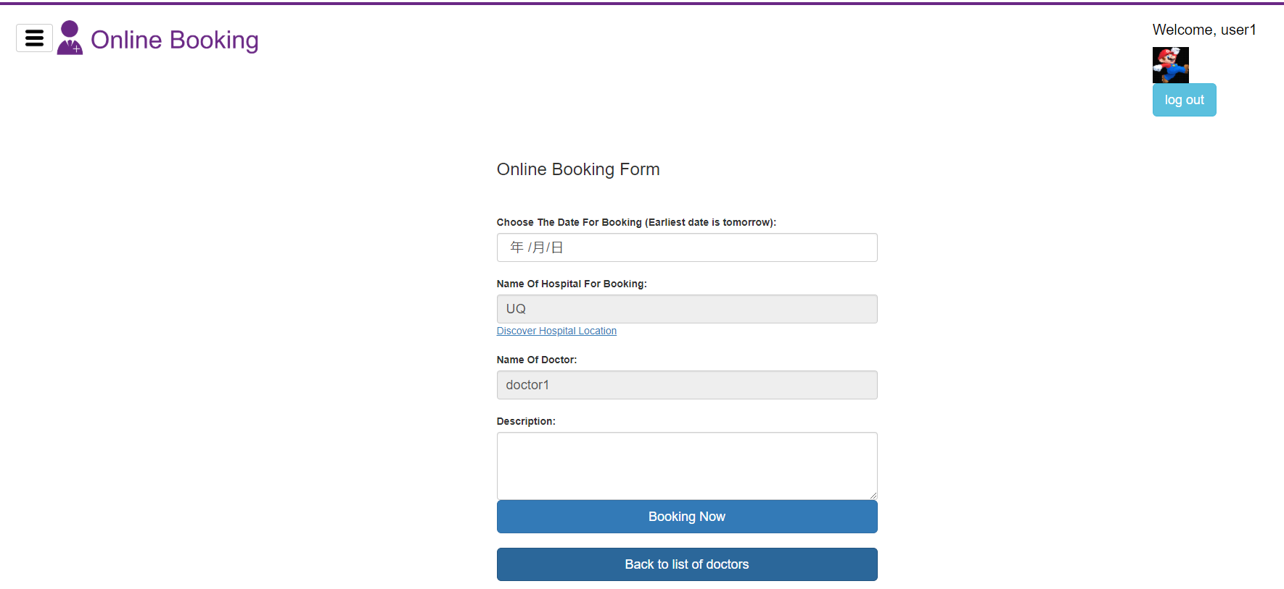

6. Patient can change their information and upload their photo at Personal Detail page.

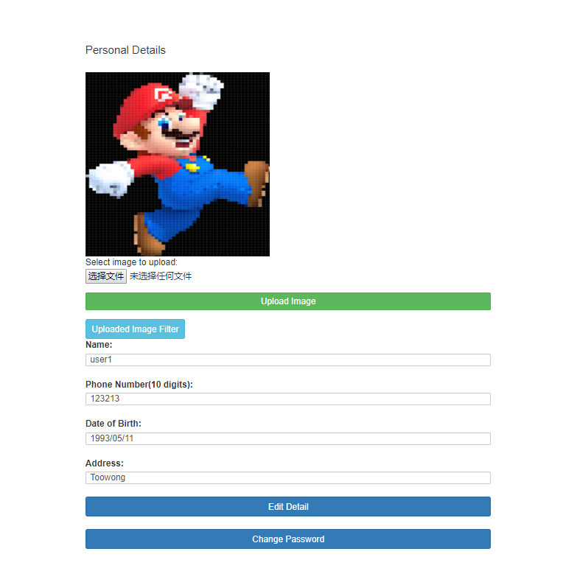

7. Doctor Booking History: Doctor can manage and see their appointment with patients here.

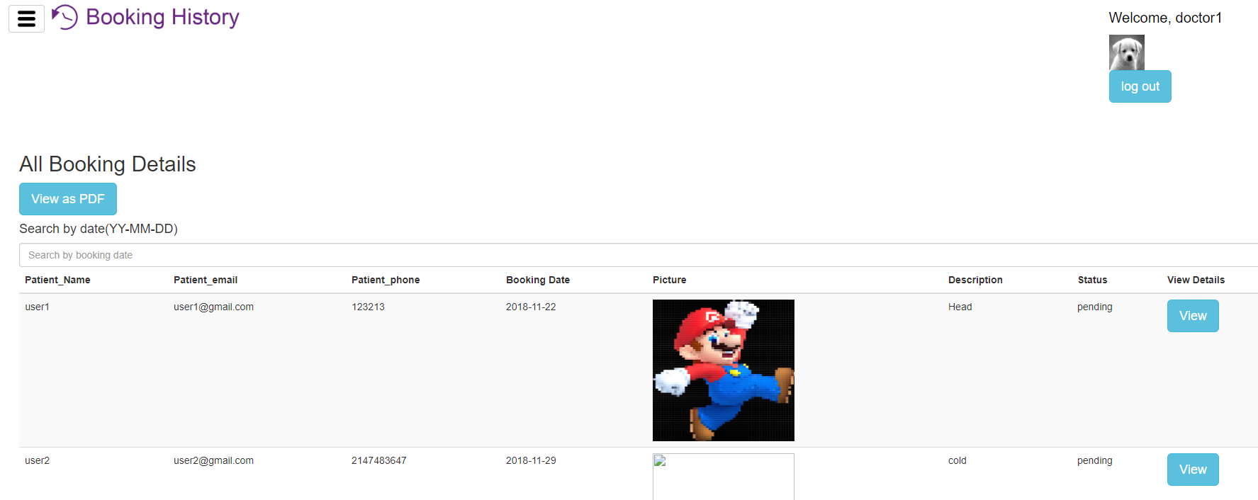

There are many other functions have not been demonstrated in this document, such as image filter, forget password…